Computer Architecture and Operating Systems

Assignment 2

-Parth Singh 2018356

**Description of what I did:**

1. I developed a client server program with the help of sockets.
2. Our server must be able to accept as well as maintain connection with single/multiple clients. Each client will be having a unique identity.
3. The client "1" will send a message "hi" and the server will be broadcasting the message " received from 1: hi" to all clients, also to the sender.
4. The clients can join and leave anytime. They can also cancel their connection with interacting with the server and also abruptly.
5. The server can go offline after informing the clients as well as abruptly.

**Description of how to compile and test the program :**

1. Run "make all" to generate executables. It executes the following commands:

* gcc 16098_server.c -lpthread -o 16098_server
* gcc 16098_client.c -lpthread -o 16098_client

1. Run "./16098_server" to start the server, input the port to listen on.
2. Run "./16098_client" to start the client, input server address and port to connect to.
3. Input "exit" to inform before cancelling the connection.
4. For localhost, use 127.0.0.1 as server address.
5. Run "make clean" to remove the exe files.

**Some inputs and the expected output:**

1. If we open the client panel then it will be asking server and port so after connecting that same port in server site then the connected to server 127.0.0.1 will be appearing.
2. Whenever a new client will be connected Started client 0 thread will appear.
3. Server will be sending hello client ‘ ‘ to each new client

**Some errors:**

1. Server port was showing error again and again even if both places had the same port.

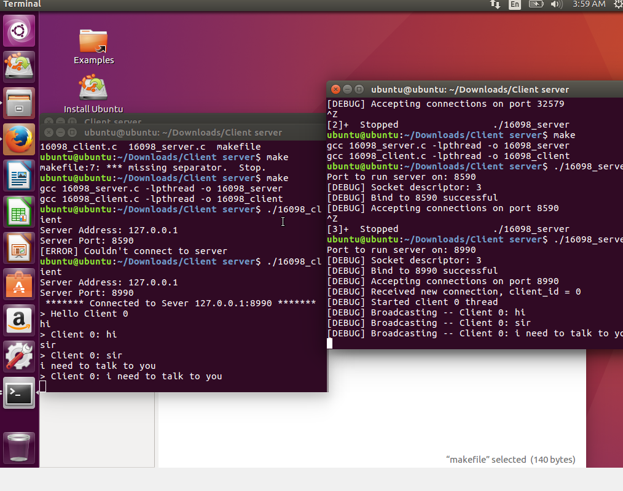

1. Again the port problem came in server part too

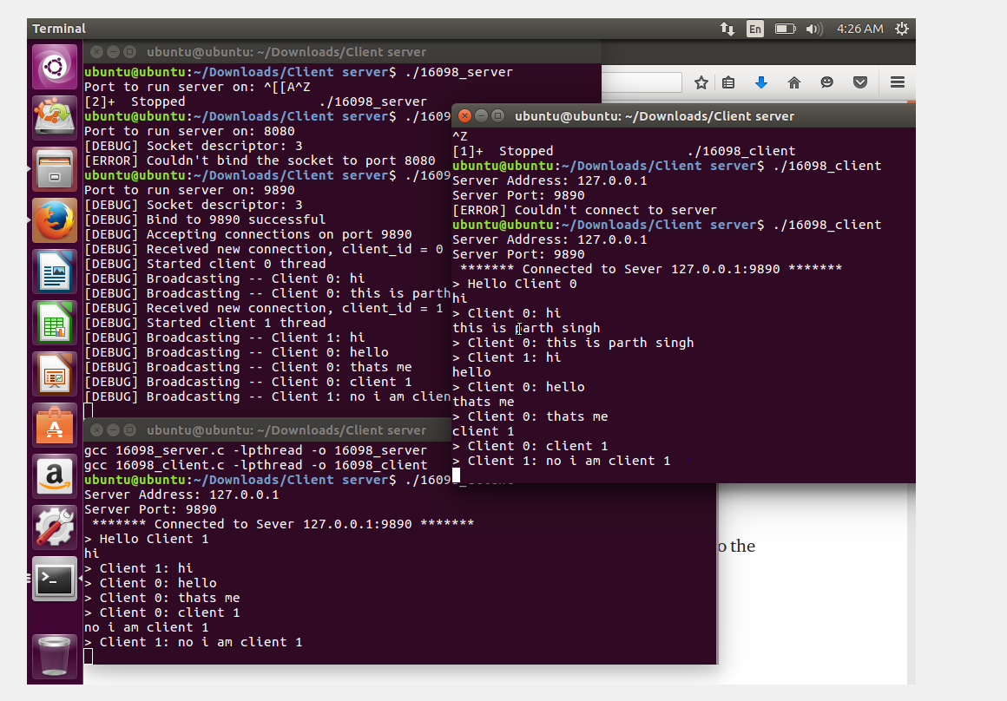

Had to edit this

if (inet_pton(AF_INET, server_addr, &(addr.sin_addr)) != 1)

{

printf("[ERROR] Couldn't resolve server address\n");

exit(EXIT_FAILURE);

}

int sd = socket(AF_INET, SOCK_STREAM, 0);

if (sd < 0)

{

printf("[ERROR] Couldn't create socket\n");

exit(EXIT_FAILURE);

}

if (connect(sd, (struct sockaddr *) &addr, (socklen_t) sizeof(addr)) == -1)

{

printf("[ERROR] Couldn't connect to server\n");

exit(EXIT_FAILURE);

}

**Code explanation:**

* #include <sys/socket.h>  //For Sockets
* #include <netinet/in.h>  //For the AF_INET (Address Family)

* struct sockaddr_in addr; //This for setting socket address
* int sd = socket(AF_INET, SOCK_STREAM, 0);

//getting socket descriptor

* int listen_ret = listen(sd, 100);

// backlog for 100 connections

* int addr_len = sizeof(addr);

int client_sd; // for incoming connection socket descriptor

* if (pthread_create(&tid, NULL, commander, NULL) != 0)

// starting commander

* void *commander(void *data)

// takes server commands